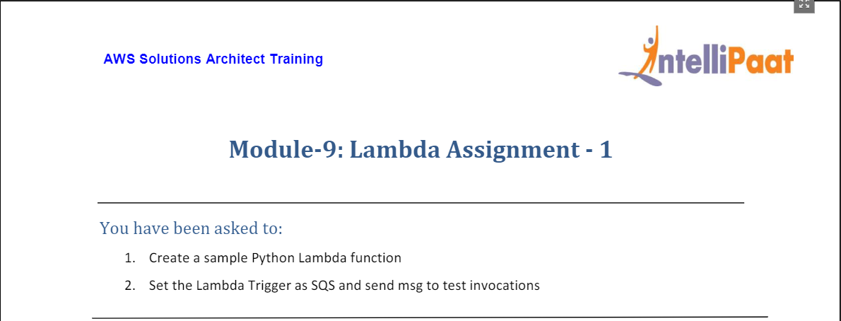

1. We head to the Lambda service through AWS Management Console and then click on create function on the right (as shown below).

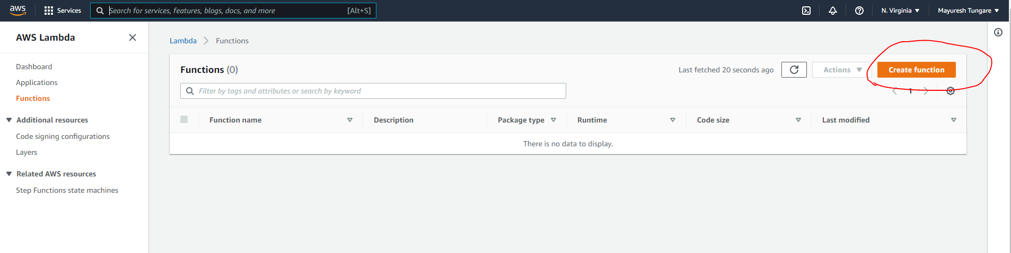

1. On the next screen, please enter information (as shown below) and then click below on create function at the bottom of the page:

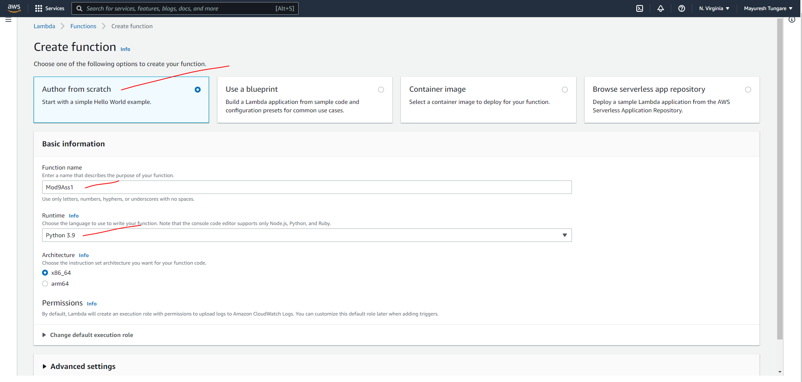

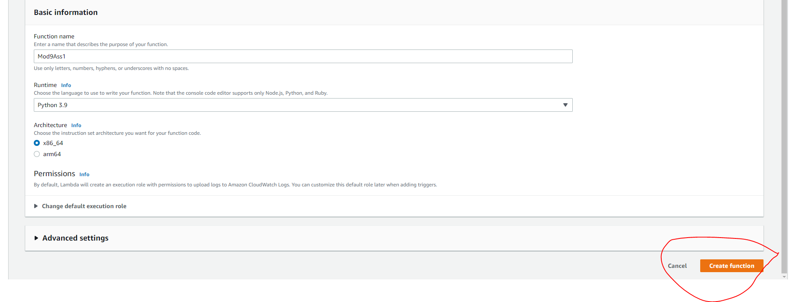

1. We have now created a AWS Lambda function which executes a simple Python function that prints “Hello from AWS Lambda” as shown below:

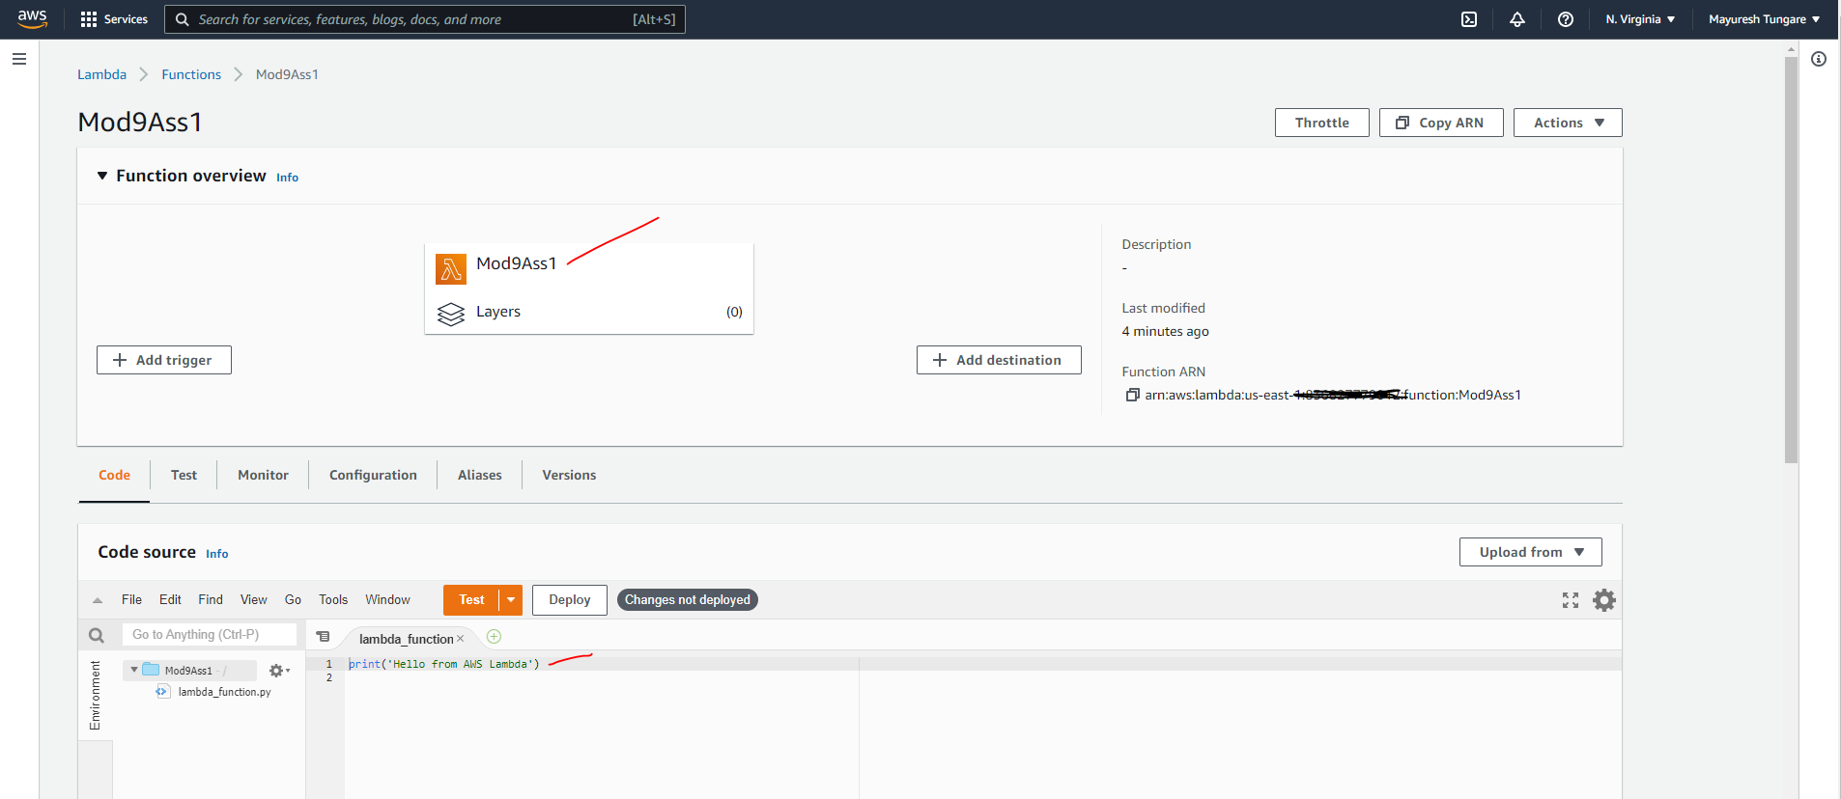

1. Now, we move to Step 2 of the assignment. We create a SQS topic that would trigger the Lambda function. For that we head to the SQS service

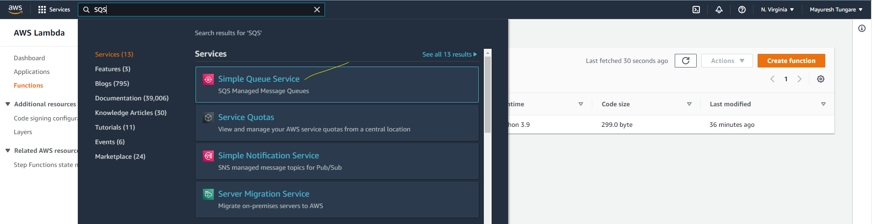

1. On SQS page, we click on Create queue as shown below:

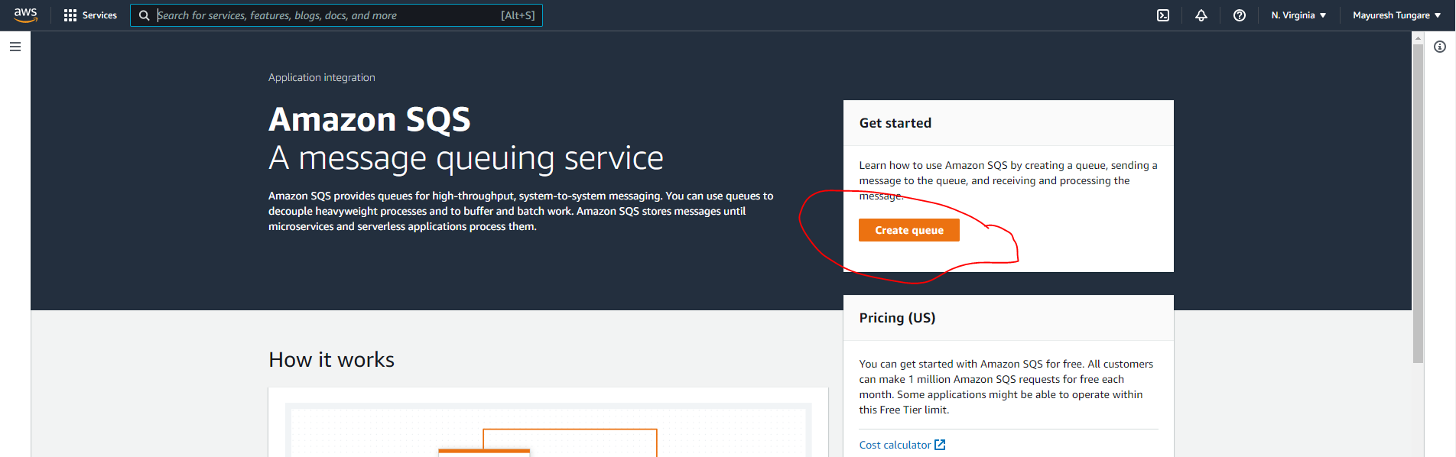

1. On the next screen, we choose a standard queue and set other parameters as shown below:

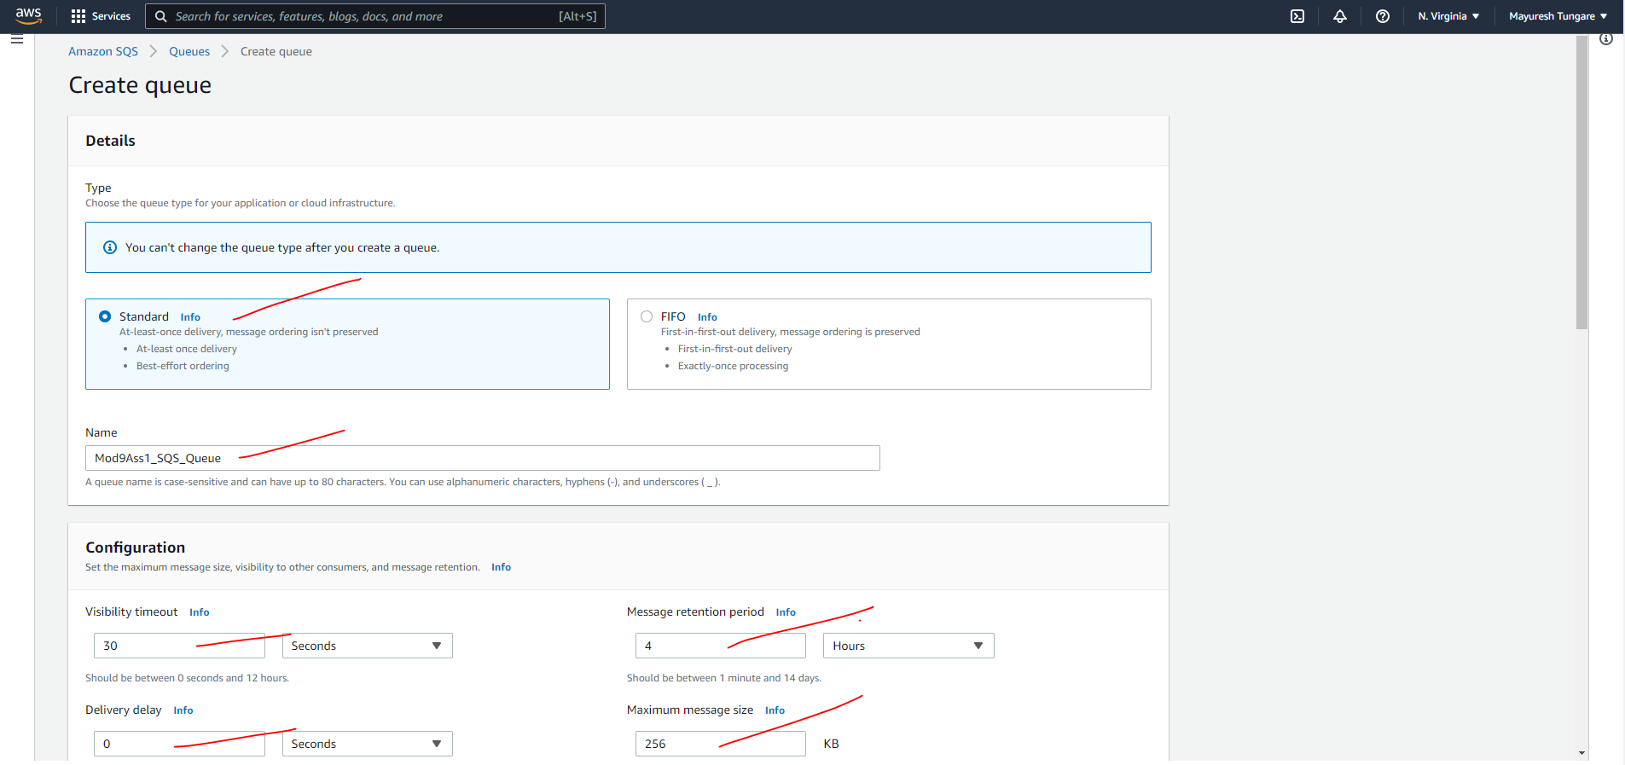

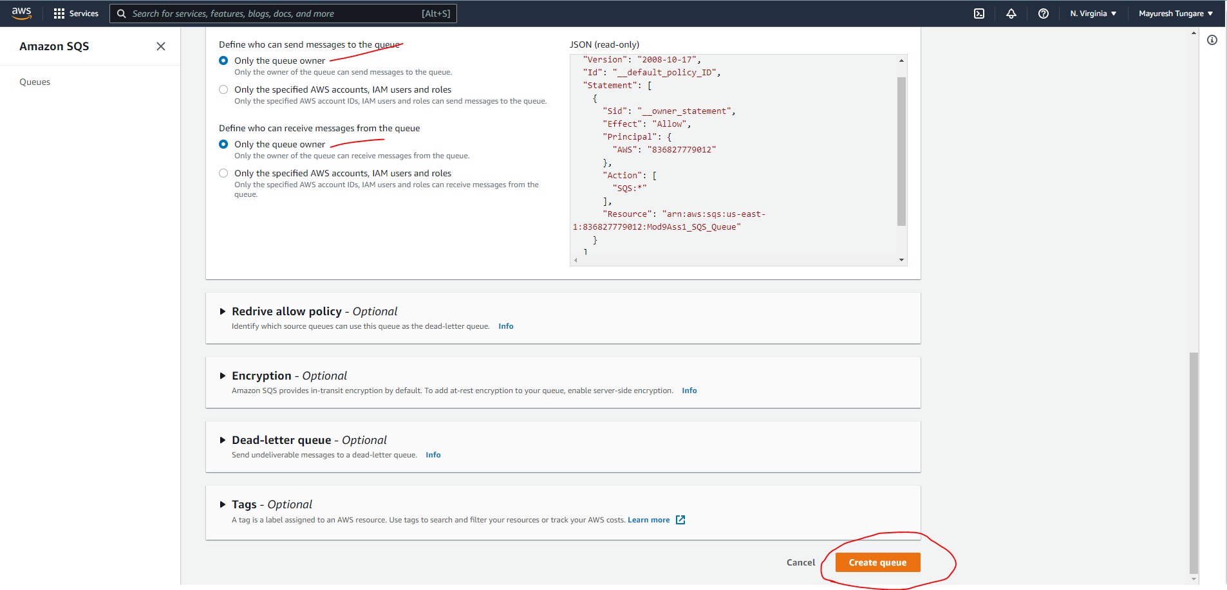

1. We see the SQS has been created – we make a note of the SQS Queue ARN.

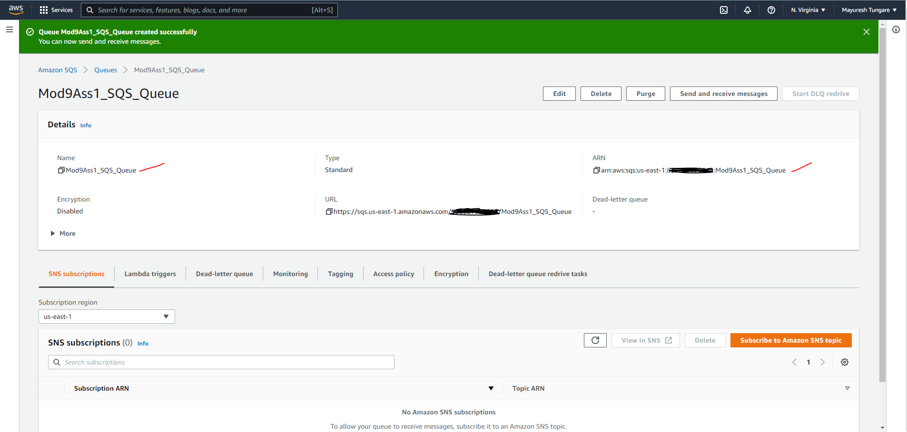

1. Next, we go to IAM to create a role for the Lambda function to poll the SQS messages. The role (sqs_lambda) is added to the Lambda function.

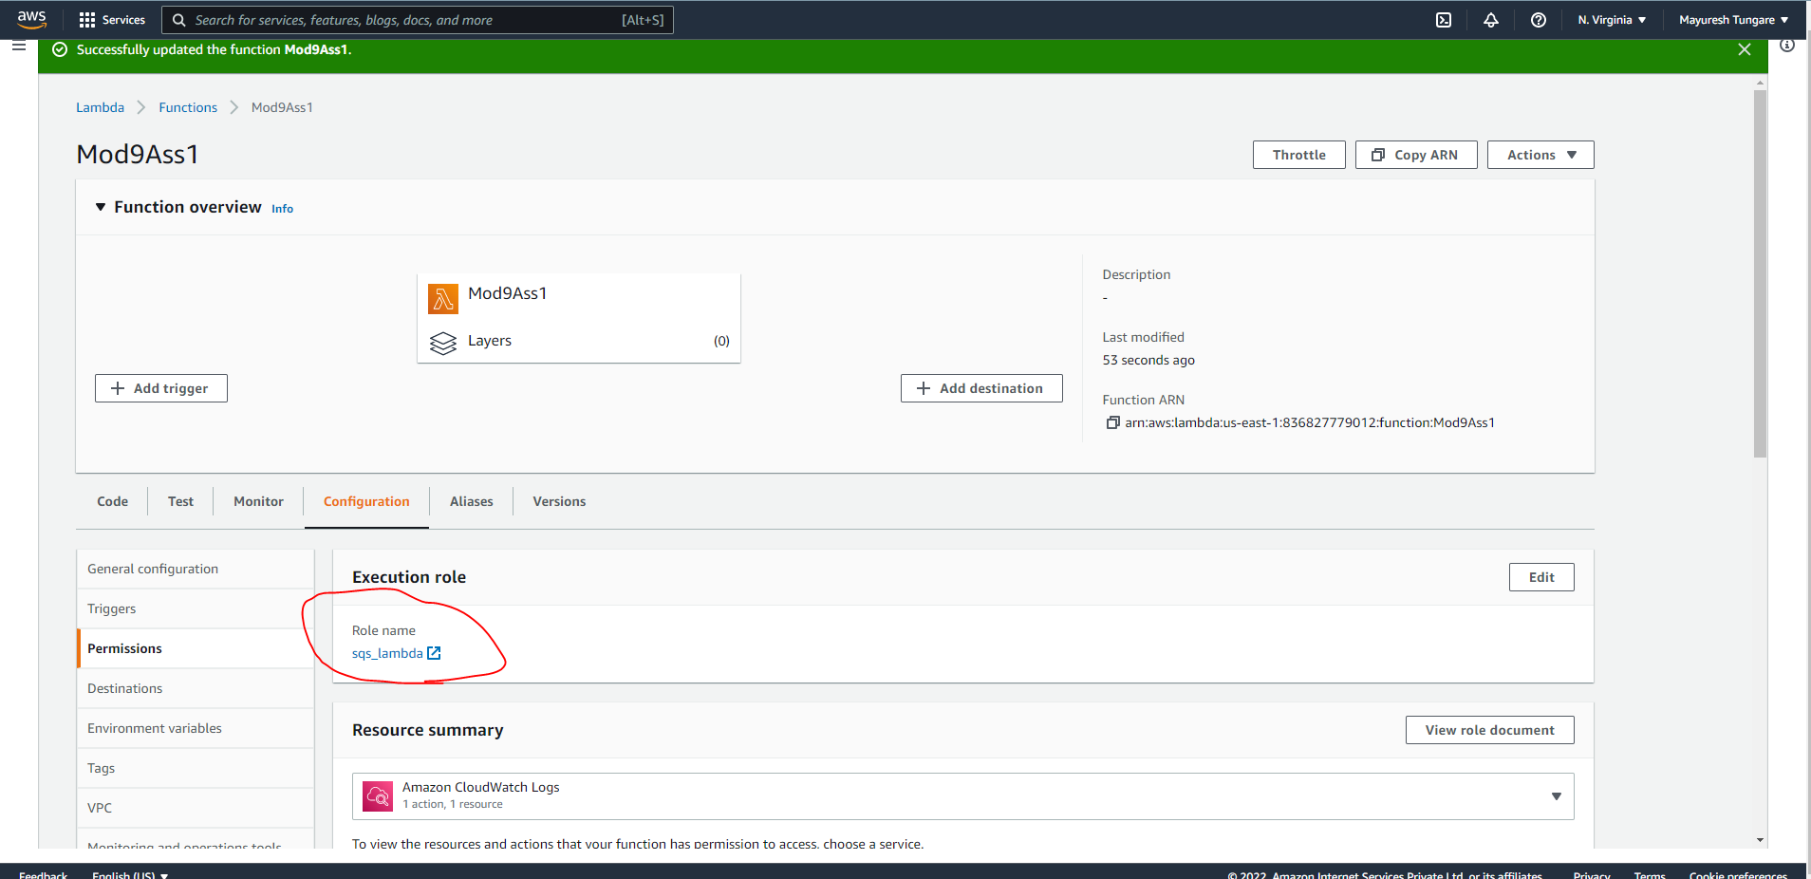

1. Next, we go to the Lambda function and set the trigger (shown below) as the SQS created in the previous steps.

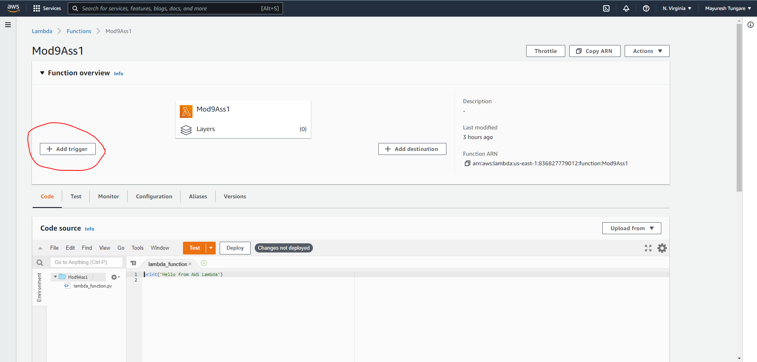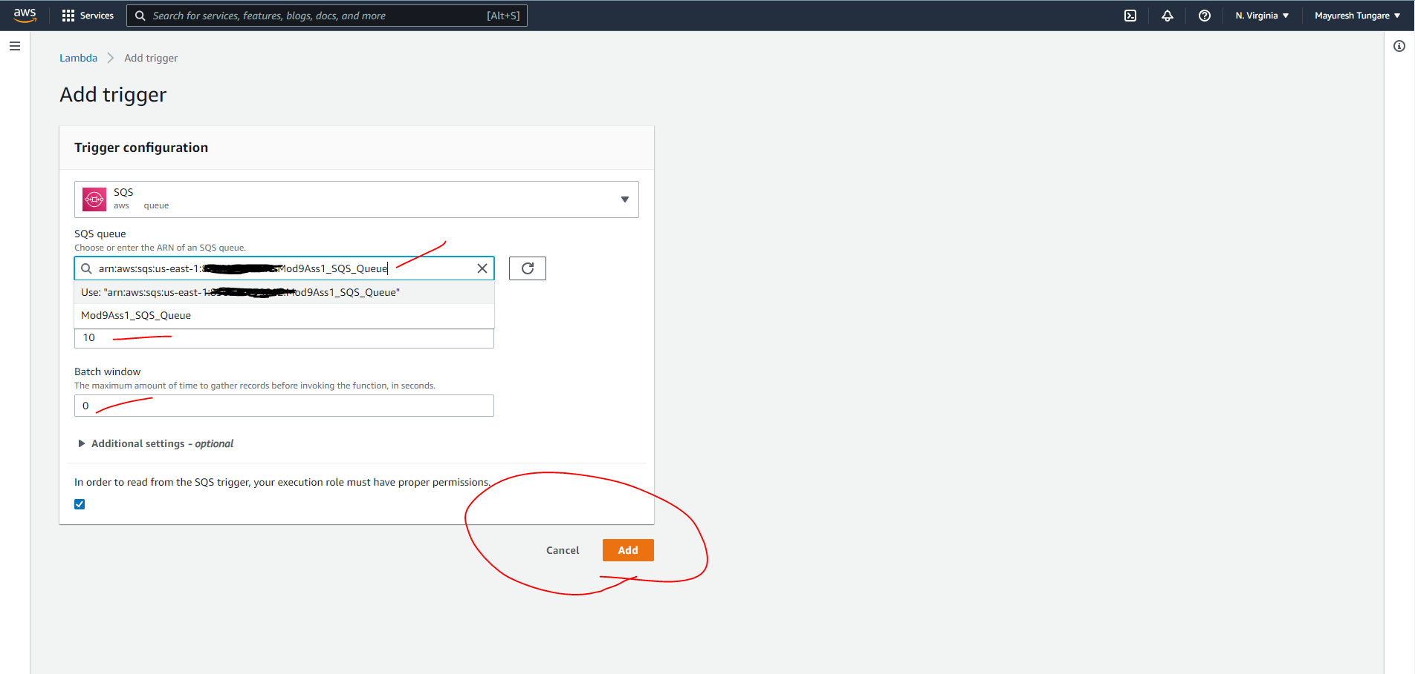

1. As we see below in the snapshot, the Lambda function is now getting triggered after receiving messages from the SQS.

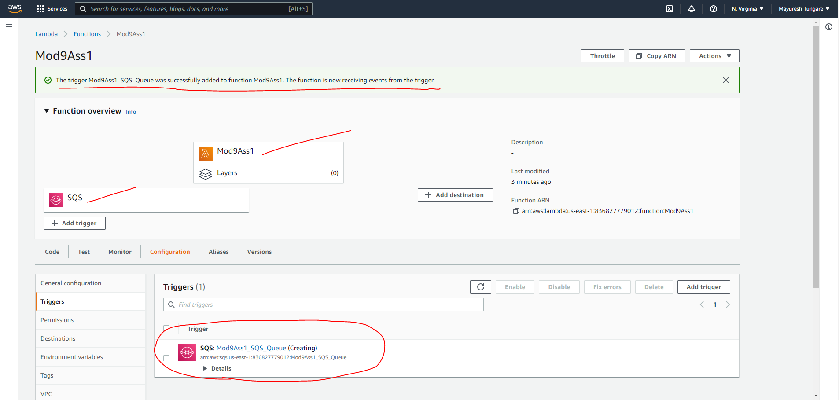

1. We now test this by sending a message to SQS and observing if the function gets executed.

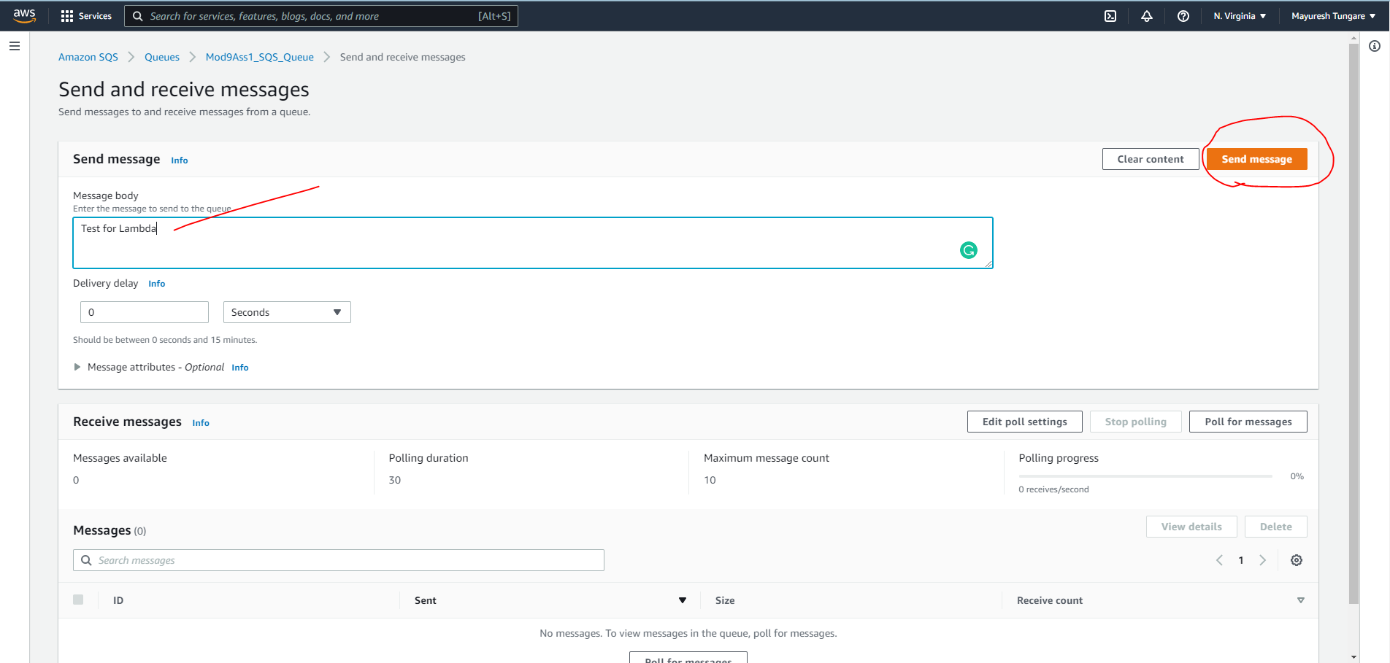

1. We now observe from CloudWatch Logs that passing the SQS triggered the Lambda function that printed the message (Hello from AWS Lambda)

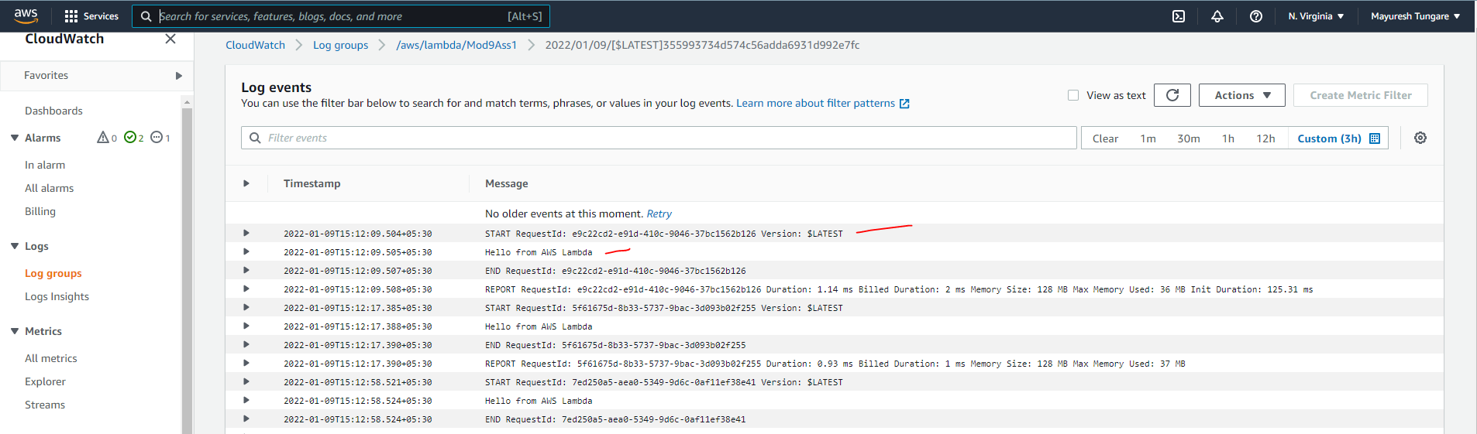

1. Thus, this assignment is now complete.